Geometry: Unit 2, Lesson 6

- What is the negation of the statement: “Some of the students have an after school job”?

Some of the students do not have an after school job.

- Does the given Venn diagram illustrate the statement: “Some cyclists are athletes”?
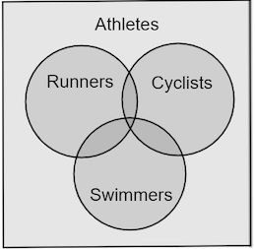

No

- What is an equivalent statement to “All poodles are dogs”?

If an animal is a poodle then it is a dog.

